Three-axis mechanical arm (link type) specification

Model：R290
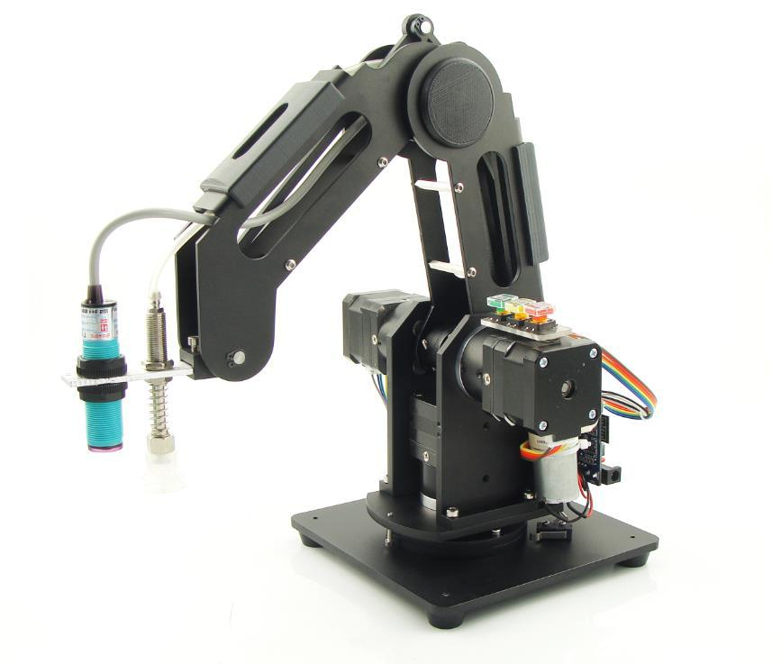
 | Specification
Axis | 3
Load | 0.5KG
Maximum stretch distance | 280mm
Repeated positioning accuracy | 0.3mm
Communication Interface | Wifi
voltage | 100-240V，50/60HZ
power input | 12V/5A DC
power | 60w max
Operating temperature | -10℃-60℃
 | Physical characteristics
net weight | 4.5kg
Base size | 155mmx155mm
material | 6061 Aluminum alloy
Controller | Android
Robot installation | Base fixing hole
Packing specification | 355x330x280mm
 | application
software | Android Apk
 | End effector
Sucker | Suction cup diameter |  | 20mm
 | pressure |  | -35kpa

